**UNIVERSITY INSTITUTE OF ENGINEERING**

**Department of Computer Science & Engineering**

**Subject Name:** DM Lab

**Subject Code:** 20CSP-376

**Submitted to: Submitted by:**

Er. Nitasha **Name:** Pratik kumar Dey

**UID:** 21BCS8183

**Section:** 20BCS_DM-718

**Group:** B

**INDEX**

|  |  |  |  |  |  |  |
| --- | --- | --- | --- | --- | --- | --- |
| **Ex. No** | **List of Experiments** | **Conduct (MM: 12)** | **Viva**  **(MM: 10)** | **Record (MM: 8)** | **Total**  **(MM: 30)** | **Remarks/Signature** |
| 1.1 | Demonstration of preprocessing on .arff file using student data .arff.. |  |  |  |  |  |
| 1.2 | To perform the statistical analysis of data. |  |  |  |  |  |
| 1.3 |  |  |  |  |  |  |
| 2.1 |  |  |  |  |  |  |
| 2.2 |  |  |  |  |  |  |
| 2.3 |  |  |  |  |  |  |
| 2.4 |  |  |  |  |  |  |
| 3.1 |  |  |  |  |  |  |
| 3.2 |  |  |  |  |  |  |
| 3.3 |  |  |  |  |  |  |

**Experiment-1.2**

**Student Name:** Pratik Kumar Dey **UID:** 21BCS8183

**Branch:** BE CSE (Lateral Entry) **Section/Group:** 718/B

**Semester:** 6th **Date of Performance:** 24/02/2023

**Subject Name:** DM Lab **Subject Code:** 20CSP-376

1. **Aim/Overview of the practical:**

To perform the statistical analysis of data.

1. **Apparatus / Simulator Used:**

* Windows 7 or above
* R Studio

1. **Objective:**

* Represent the reading of file using R Studio.
* Displaying the pattern on Weka Tool.
* Find mean, median and standard deviation of particular columns.

1. **Script and Output:**

***Code:***

library(Rweka)

N=read.arff(''Student_frame.arfr')

print(N)

cat("\n") #used to skip lines

print(head(N,2)) #used to print first 2 rows

print(tail(N,3)) #used to print first 3 rows

cat("\n")

dim(N) #used for finding dimensions

names(N)

N["Name")

cat("\n")

max(Math_Marks) #maximum from column

min(Science_Marks) #minimum from column

cat("\n")

mean(Eng_Marks ) # mean

Median lath_Marks) # median

(cial_sci_Marks) # standard deviation

cat("\n")

summary(N)

***Output:***

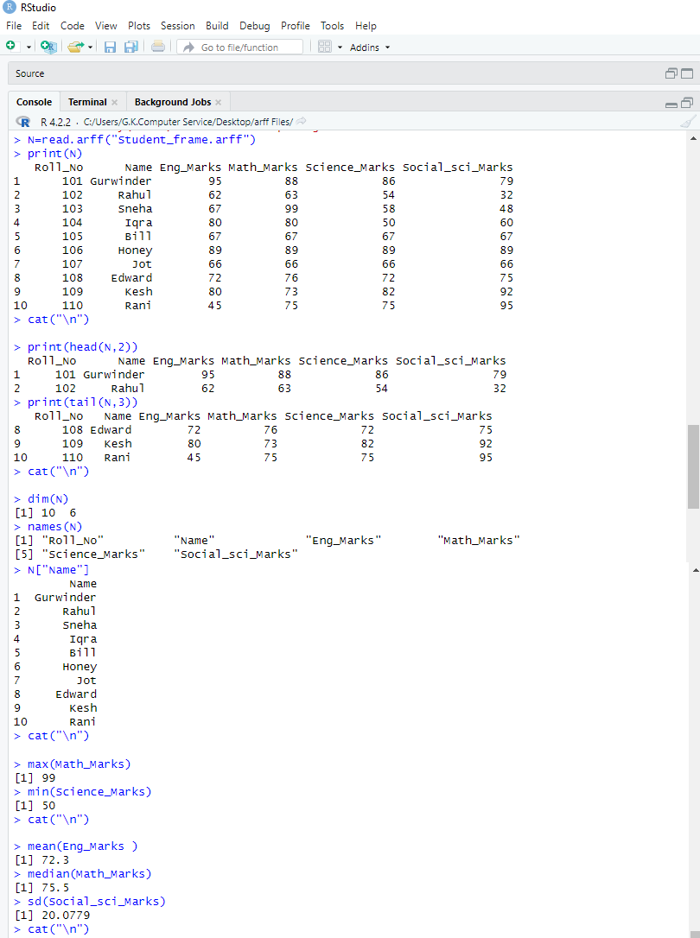

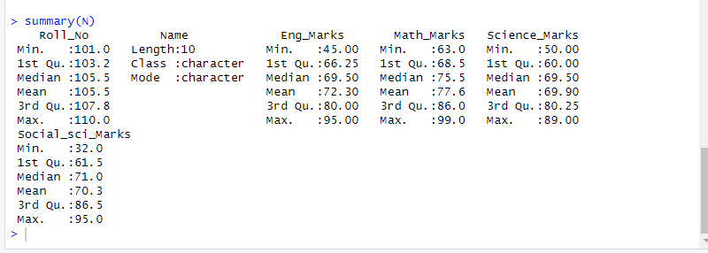

**Evaluation Grid (To be created as per the SOP and Assessment guidelines by the faculty):**

|  |  |  |  |
| --- | --- | --- | --- |
| Sr. No. | Parameters | Marks Obtained | Maximum Marks |
| 1. |  |  |  |
| 2. |  |  |  |
| 3. |  |  |  |
| 4. |  |  |  |

**Conclusion:-**

I have successfully completed this experiment.